YEAR 11 GENERAL HUMAN BIOLOGY

DO NOT MARK THIS BOOKLET

Multiple Choice 20 Marks

Short Answer 20 Marks

Total 40 Marks

Task 2: Cells and Test

Which of the following is true of **all** cells?

(a) Cells are basically the same in structure, yet differ in shape and

function (What they do).

(b) All cells have a cell wall.

(c) Cells differ greatly from organism to organism.

(d) All cells have chloroplasts for making food.

Which of the following cell organelles would you expect to be LESS numerous in a bone cell than in a skeletal muscle cell?

(a) Mitochondria.

(b) Nuclei.

(c) Vacuoles.

(d) Ribosomes.

[Grab your reader’s attention with a great quote from the document or use this space to emphasize a key point. To place this text box anywhere on the page, just drag it.]

Two human cells A and B were examined using a microscope . With the lens combinations shown , both just filled the field of vision.

Animal ocular lens Objective lens

A 5 10

B 10 50

The observer should correctly conclude that:

1. A was much bigger than B
2. A and B were the same size
3. B was 5 times the size of A
4. B was much bigger than A.

Is the statement ‘ an increase in salt concentration will decrease cell sizes’ a

(a) theory

(b) hypothesis

(c) result

(d) experimental design

In multicellular organisms tissues can best be described as:

(a) groups of systems which cooperate in a series of larger functions.

(b) groups of cells all of which have a similar structure and which usually perform a similar function.

(c) only cells that are involved in protective coverings and cavity linings.

(d) groups of organs all of which perform the same function.

The type of tissue lining the digestive tract is

1. epithelial tissue
2. connective tissue
3. muscular tissue
4. contractile tissue
5. Any group of cells of similar structure and that perform a specific task are called
6. a system
7. a tissue
8. an organ
9. a nerve

The generalised equation for respiration is:

**Glucose + X → Carbon dioxide + Water + Energy.**

In the generalized equation above X represents

1. Sugar
2. Water
3. Oxygen
4. Amino Acids

The process by which a substance spreads from an area of high concentration to an area of low concentration is known as

1. pinocytosis
2. osmosis
3. active transport
4. diffusion

6. Which of the following is the site for aerobic respiration?

1. nucleus
2. cytoplasm
3. mitochondria
4. ribosomes

**Question 43 refers to the diagram below.**

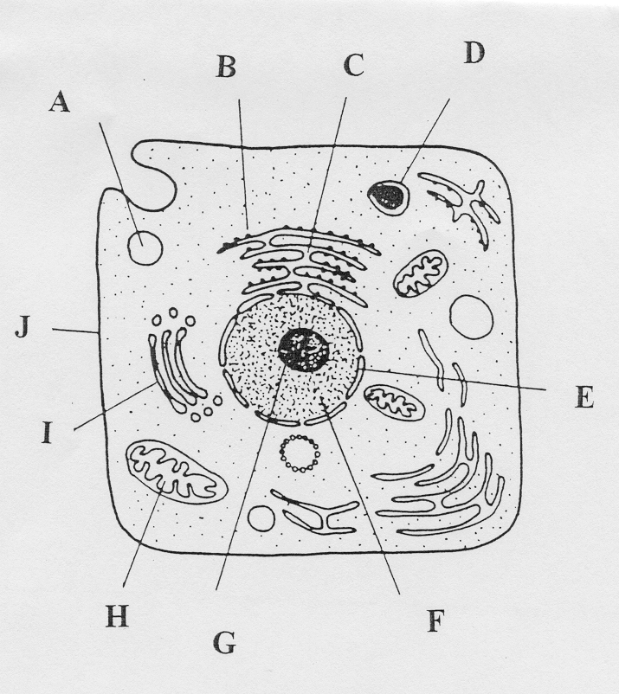

43a. Complete the labels from the diagram above.

B_______________________ C ___________________________

E_______________________ F____________________________

#### G_______________________ H____________________________

I________________________ J_____________________________

( 8 marks)

1. Explain the function of the following structures.
2. B_______________________________________________________________

________________________________________________________________

1. F_________________________________________________________________________________________________________________________________
2. H__________________________________________________________________________________________________________________________________
3. J___________________________________________________________________________________________________________________________________

( 4 marks)

1. Name the type of instrument used to observe the cell represented.

______________________________________________________________

( 1 mark)

d Write the word equation used to represent cellular respiration.

_____________________________________________________________

( 1 mark )

e Name the following types of tissue shown.

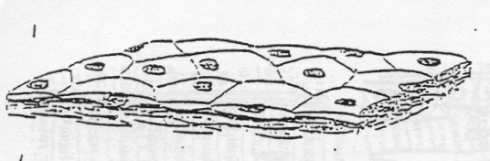

i)____________________________________



ii)_____________________________________

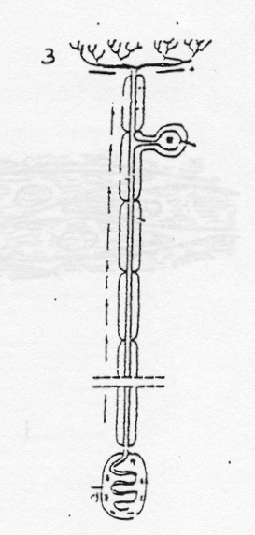

iii)__________________________________________

(3 marks)

f Where would you find?

Tissue 1 _________________________________________________________

Tissue 2__________________________________________________________

##### Tissue 3_________________________________________________________

( 3 marks)

1. What is the function of:

Tissue 1_________________________________________________________

Tissue 2_________________________________________________________

Tissue 3_________________________________________________________